Volunteer Profile

Dog & Cat Shelter, Inc.

84 East Ridge Rd, Sheridan WY 82801

307-674-7694 www.dogandcatshelter.org

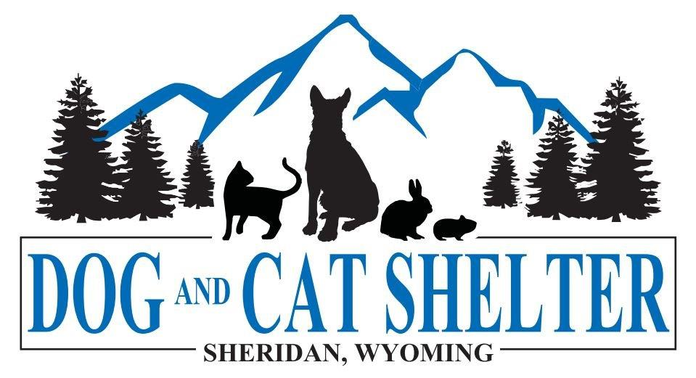

The Dog & Cat Shelter of Sheridan, Wyoming is a private, nonprofit animal welfare organization. Our mission is to provide a shelter where unwanted and abandoned dogs and cats can be humanely housed until adopted to qualified homes. Please complete all pages of this profile and sign and date the waiver.

Name (Please Print): _____________________________________________________________

Mailing Address: ________________________________________ City/State/ZIP ________________________________

Home Phone: ______________________ Cell Phone: _______________________ email: __________________________

Age (if under 21): ______________ Date of Birth: _______________

Name of parent(s) or guardian: _______________________________________________________

A parent or guardian who is either a Shelter volunteer or attends the class is required for every potential volunteer who is under 18 years of age. After taking the class, volunteers who are 16 years or older do not need to have a parent or guardian present when they are volunteering. All volunteers under 16 years of age will need a parent or guardian, whoever takes the class with them, with them when they volunteer. Some exceptions can be made, on an individual basis and with parental consent, if the volunteer is 14 to 16 years of age and has been accompanied during his or her volunteer time by the parent or guardian for a month (approximately 20 hours) or longer. Please note dog walking requires extra orientation.

Person to contact in case of emergency: ____________________________________________

Phone: _________________________________ Relationship: ____________________

Do you have any specific skills or training pertaining to animals? (obedience trainer, grooming, vet tech, pet owner…) _____________________________________________________________________________

Are there any animal situations that you are uncomfortable working with? (Large dogs, cats…)
_____________________________________________________________________________

Do you have any allergies to animals or disinfectants/cleaners?
_____________________________________________________________________________

The staff at the Shelter works very hard. Would you be willing to take care of and clean animals on an occasional holiday or during times when the staff are on vacation?
NO YES (This may require a bit of extra training.)

Have you ever been convicted of a crime and/or felony? NO YES (If yes please explain.)
_____________________________________________________________________________
Are you interested in our Foster program? NO YES (If Yes the Foster Coordinator will contact you with more information.)

Liability Waiver and Release

I acknowledge that the activities involving animals in the custody of the Dog and Cat Shelter, Inc., are inherently dangerous and agree to assume all risks of injury, death, and damages that may result from all such activities at or in conjunction with the Dog and Cat Shelter, Inc.

Except as to individual insurance, if any, I do for myself, my heirs, and representatives, fully and completely release the Dog and Cat Shelter, Inc., its employers, officers, and directors, of any and all claims for losses, damages, injuries and claims compensation, of any kind, that may arise in connection with any activity at or associated with the Dog and Cat Shelter, Inc. This release shall apply regardless of the negligence or fault of the entities or persons released hereby.

I do further agree to indemnify, protect, and hold harmless, all persons and entities released in the above paragraph from all such claims as are released hereby and from any breach of this release by me, my heirs or representatives, as well as from all expenses, including legal fees, incurred by such persons or entities as are release, as a result of any such released claim being asserted or breach of this liability waiver and release. This covenant if indemnification shall apply regardless of negligence or fault of the entries or persons released by me.

This release shall be effective upon its execution by me and shall remain in force and effect until expressly revoked by me and such revocation is accepted by the Board of Directors of the Dog and Cat Shelter, Inc.

Signed: ________________________________________________________
Print name: ____________________________________________________
Parent or Guardian (if under 18): ___________________________________
Print name: ____________________________________________________
Date: ________________ Witness: ___________________________

